Girls Soccer Championship Shirts

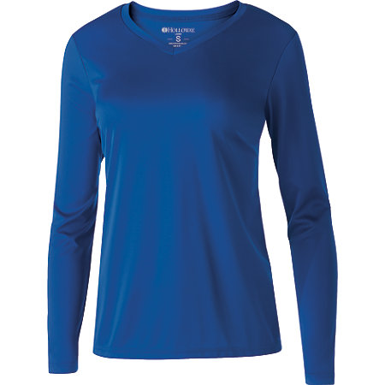

Color Royal

- Dry-Excel™ wicking polyester knit fabric with mechanical stretch
- Value price option
- V-neckline
- Fit Type: Semi-Fit

COORDINATING
- Adult - 222521

Name of Student: __________________________________________

# of Uniform (place on right chest) _____________________________

Size of Shirt (Adult sizes)

XS S M L XL 2XL

